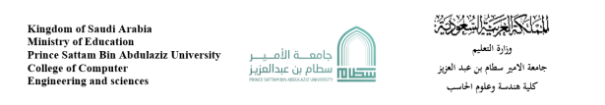

Google Application

Project

|  |  |  |
| --- | --- | --- |
| **N** | **Student Name** | **Student Number** |
| **1** | **Mishal Majed Almilwith** | **442050094** |

**Supervised by : Dr.Mohammed Assiri**

**Parts**:

**Introduction**

Google is a technology giant that has developed numerous successful applications used by millions of people around the world. As such, the feasibility of developing a new Google application is high. This report outlines the problems and challenges associated with developing a new Google application, as well as the background, proposed solution, and work plan for addressing these challenges.

**Problems**

The development of a new Google application comes with several challenges, including:

1. Competing with existing Google applications: Google already has a wide range of applications that are popular and widely used. Developing a new application that can compete with these existing applications may be challenging.

2. Meeting user expectations: Users have come to expect high-quality, user-friendly applications from Google. Developing a new application that meets these expectations may require significant resources and expertise.

3. Ensuring compatibility: Google applications need to work across a variety of devices and platforms, so ensuring compatibility with multiple operating systems and devices may be challenging.

**Background**

Google has a proven track record of developing successful applications, such as Google Search, Gmail, Google Maps, and Google Drive. These applications have become an integral part of many people's lives and have revolutionized the way we search for information, communicate, navigate, and collaborate. However, there is always room for improvement, and developing a new Google application that addresses a specific need or solves a particular problem can provide significant value to users.

**Proposed Solution**

To address the challenges associated with developing a new Google application, we propose the following solutions:

1. Conduct market research: Before developing a new application, it's essential to conduct market research to understand the needs and preferences of potential users, as well as the competition.

2. Focus on user experience: To meet user expectations and compete with existing Google applications, the new application should prioritize user experience and focus on ease of use, simplicity, and intuitive design.

3. Ensure compatibility: The new application should be designed to work across multiple platforms and devices, including desktops, laptops, tablets, and mobile devices.

4. Leverage Google's existing resources: Google has a vast team of experienced engineers and designers, as well as extensive infrastructure and access to user.

**Work Plan**

To develop a new Google application, the following work plan is proposed:

1. Conduct market research to identify user needs and preferences, as well as the competition.

2. Define the scope and requirements of the new application, including features, functionality, and compatibility.

3. Develop a user interface design that prioritizes ease of use, simplicity, and intuitive design.

4. Develop a prototype of the new application and conduct user testing to ensure that it meets user needs and preferences.

5. Refine the application based on user feedback and conduct additional testing as necessary.

**Project requirements:**

**Functional Requirements:**

1. The application must allow users to search for information using keywords or phrases.

2. The application must allow users to customize their search settings, such as language, region, and search filters.

3. The application must provide relevant and accurate search results based on the user's query.

4. The application must allow users to access their Google account and use its associated features, such as Gmail and Google Drive.

5. The application must allow users to send and receive emails using their Google account.

6. The application must provide users with a mapping feature that allows them to navigate to a specific location and view directions.

7. The application must allow users to save and share files using their Google Drive account.

8. The application must provide users with productivity tools, such as document creation and collaboration features.

**Non-Functional Requirements:**

1. The application must be compatible with multiple operating systems and devices, including desktops, laptops, tablets, and mobile devices.

2. The application must be responsive and provide a consistent user experience across all platforms and devices.

3. The application must be secure and protect user data and privacy.

4. The application must be scalable and able to handle a large volume of users and data.

**Activity Diagram(Search System):**

User opens

application

User closes  
application

User selects

“Search”

User selects  
Search result to view

Application displays selected search result

User enters

Search query

Application processes and returns results

**Project Use Case Modeling(Search System):**

USER

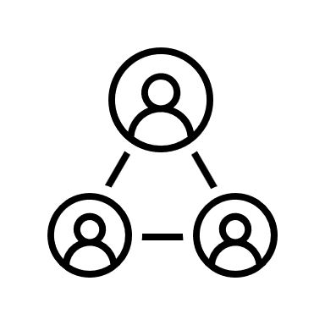 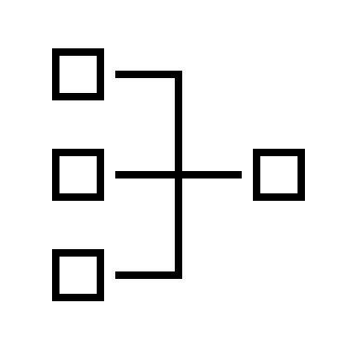

USER

Application Search System

|  |  |
| --- | --- |
| Actors | User , Application Search System |
| Description | The user wants to find information about a particular topic. |
| Stimuls | User enters search query into the application. |
| Search System | Application Search Server, Index Server, Ranking Server |
| Response | Relevant search results are displayed to the user. |
| Comments | This is the most common use case for a search application. |

 

USER

Application Search System

|  |  |
| --- | --- |
| Actors | User , Application Search System |
| Description | The user wants to save their search results and access them across multiple devices. |
| Stimuls | User selects the save and sync feature provided by the application. |
| Search System | Application saves search results to the user's account. |
| Response | Saved search results can be accessed from any device where the user is logged in. |
| Comments | This feature requires the user to have an account with the application, and may require additional authentication for security purposes. |

**Creating Sequence Diagrams:**

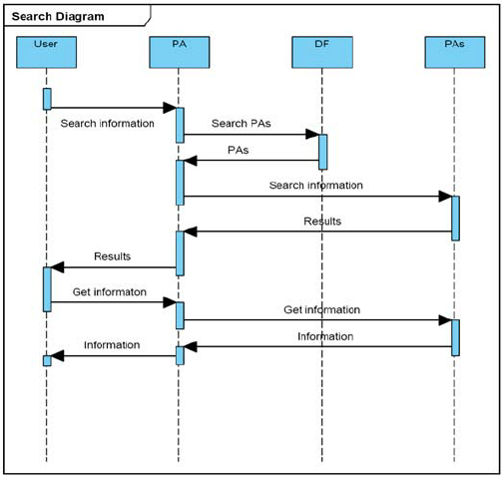

**Creating a Class Diagram:**

